Configuring your tablet as a signature pad for CashierLive

Now you can use your iPad, iPad mini or other tablet* as a customer-facing pole display and signature capture device. Configuring your device in this manner can be accomplished in 3 easy steps and should take less than 5 minutes. Follow the instructions below. If you have any questions, help is available at support@cashierlive.com or 877-312-1750.

STEP 1 – Configure register to use tablet as pole display and signature capture device
- Log into your register on your PC with an administrator account at https://www.cashierlive.com/cashregister/
- Select the register to configure from the left tree menu
- Change Pole Display to ‘iPad’
- Change Signature Pad to ‘iPad’
- Click ‘Save’
- Click ‘Go’ next to either ‘Permanently set this computer…’ or ‘Temporarily set this computer…’

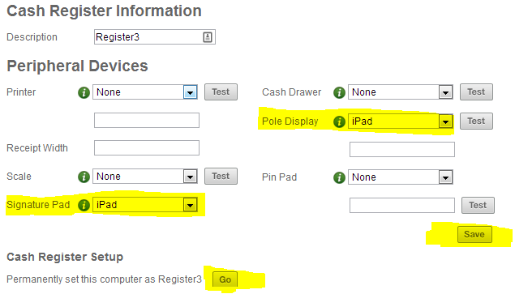

STEP 2 – Configure shortcut on tablet
- iOS
  - Open safari and browse to https://ww4.cashierlive.com/cashregister2/ipadsig.aspx?storeid=[VALUE FROM CASHIER LIVE SUPPORT]
  - Tap the bookmark icon, then the ‘Add to Home Screen’ icon
  - Change text from ‘Favorites’ to ‘Cashier Sig Pad’ (or whatever will help you remember), then click ‘Add’
  - A shortcut will be added to your device that will launch the page in full screen mode
- Android
  - TBD

STEP 3 – Log in on tablet
- Launch Safari from your newly saved shortcut
- Log in to the system with any cashier credentials for that store.
- Select the register to which this signature pad will be tethered, then click ‘Connect’

OPTIONAL STEPS
With an iOS device, you have the ability to “Lock” the device on an app. This will prevent users from closing the app by pressing the hardware button. The app can be closed by triple-tapping the hardware button and entering a user-defined passcode.

To enable:
- Go to Settings General Accessibility Guided Access
- Enable Guided Access and set a passcode
- Close settings app, launch signature pad app from shortcut
- Triple-tap hardware button
- Select options you’d like to enable on bottom of screen. CashierLive recommends only enabling ‘Touch’.
- Click the ‘Start’ button in top right corner
- Your device is now “locked” to this app only. To exit this mode, triple tap the hardware button and enter your PIN.

*NOTE: This feature has been optimized for iOS devices (iPads). We don’t guarantee this will work on Android or Windows tablets. We also are unable to ensure the signature and pole display screens will display properly on those devices.

